Document on Appium Installation Mac OS and How to run the test cases

Contents

Contents 1
Preconditions to setup Appium on Mac OS Machine: 2
Xcode Configuration in Mac OS: 2
Appium iOS setup: 3
Appium settings and configuration: 4
Appium Inspector: 5
Eclipse Kepler Release2: 6
Supported jar files to be added in the Ecplise: 6
Below are the steps for adding the external jar files to the project: 6
Running the test cases in Ecplise: 7

Preconditions to setup Appium on Mac OS Machine:

The following should be installed, before going to setup APPIUM.

- MAC OS X 10.10.5 or Higher
- Jdk 1.7
- Xcode 6.4 or Higher
- Command line tools 6.4 or Higher
- Appium.app 1.4.8
- Node.js
- Eclipse Kepler Release2
- TestNG Framework

Xcode Configuration in Mac OS:

Please follow the below instructions to setup the Xcode.

- Download Xcode from the Apple App Store and install the Xcode.
- Move the Xcode app to applications in the Mac OS machine.
- After installation open Xcode program.
- Click on “Xcode” button at the top left side of the screen.
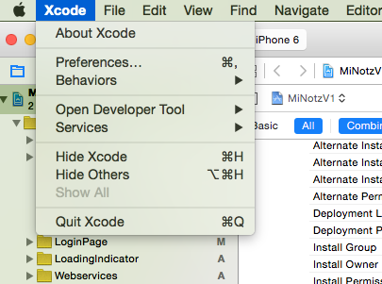

- Click the “Preferences…” button as shown in the above screen.

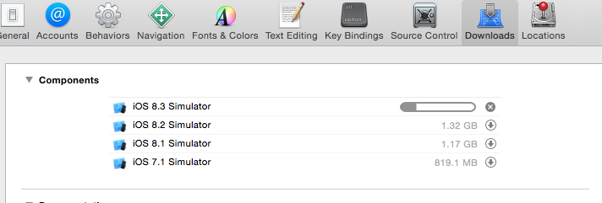
- Download all simulators from “Downloads” window that will appear.in the above screen shot.
- Download “Command Line Tools” from Apple Store based on Xcode version and install.

Appium iOS setup:

Install the node.js using below command in terminal:
$ sudo npm install wd
Download the Appium.app from below site:
http://appium.io/
Install the appium.app and move it to applications in the mac system
Open the appium and click on the doctor icon to install all the Xcode and node setup.
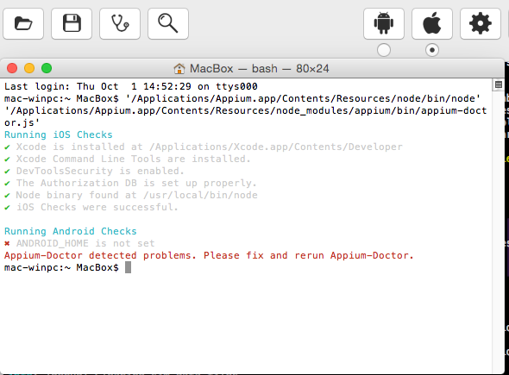

Appium settings and configuration:

- Appium server gets started in the default port 4723 and IP Address 0.0.0.0
i.e., [http://0.0.0.0:4723] in settings
- Change the default IP address to 127.0.0.1 and port 4723

Then we should get the below screen when we click on the settings icon.

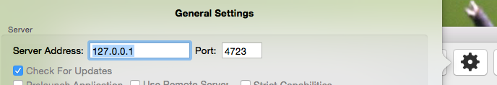
Click on the Apple icon will get the below screen:
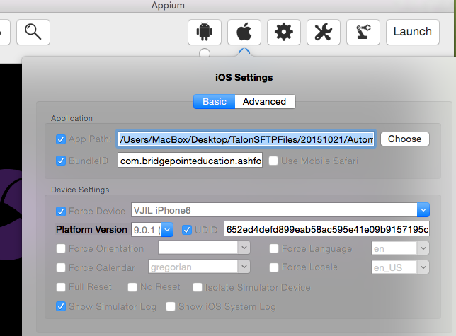
- Now, enable the check box, 'App path' in the apple icon.
- Click on the 'Choose' button and locate the application .ipa file path from local directory.
- Enable the Bundle Id and give the bundle identifier.
- Enable the Force device and choose the device name.
- Give the platform version.
- Enable the UDID and give your device UDID
- Now, click on the 'Launch' button → then now Appium starts the server

Appium Inspector:

- Click on 'inspector' button in Appium inspector

Appium Inspector is a record and play back option, Inspector connects to your device or simulator and gives you quick access to the web elements of the application you are running and enables quick testings of actions appium enables you to swipe, tap, etc.. and
Every action will be generating a script at the bottom of the Appium inspector.

Eclipse Kepler Release2:
Download the Eclipse kepler R2 from the website and install.
Install TestNG in Eclipse:
- Launch the Eclipse IDE and from Help menu, click “Install New Software”.
- Will see a dialog window, click “Add” button.
- Take the name as “TestNG” and type “http://beust.com/eclipse/” as the location. Click OK.
- Click on TestNG and press “Next” button.
- Click “I accept the terms of the license agreement” then click Finish.
- Security warning may or may not be encountered, if in case you do just click OK.
- Click Next again on the succeeding dialog box until it prompts you to Restart the Eclipse and Click OK.

Supported jar files to be added in the Ecplise:

- gson-2.4.jar or Higher version
- java-client-3.2.0.jar or Higher version
- selenium-server-standalone-2.47.1.jar or Higher version
- selenium-java-2.48.2.jar or Higher version
- testng-6.1.1.jar or Higher version
Note : Above jars are first to be downloaded and added to each project from specific location.

Below are the steps for adding the external jar files to the project:

- Right click on the project >> Build Path.
- Click on the Configure Build Path.

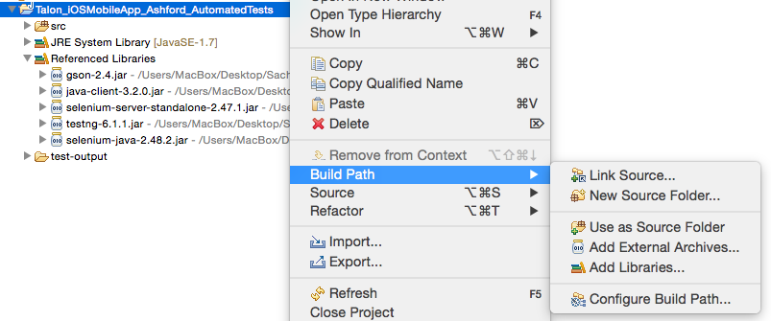

- Click on Add External JARs from java build path window and choose the respective jar file from local directory.
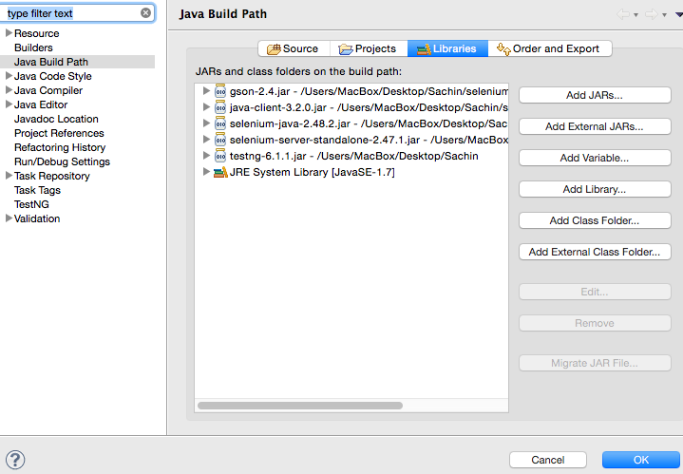

Running the test cases in Ecplise:

Note: Respective Device Setup parameters in the project should match with the Appium parameters to launch the application in the device.
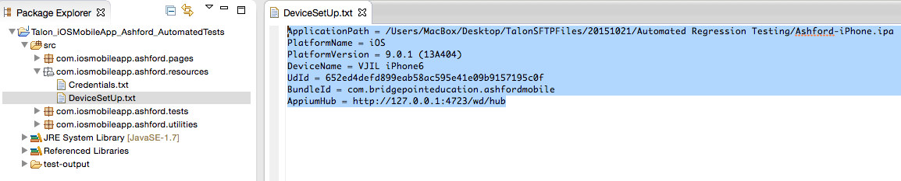

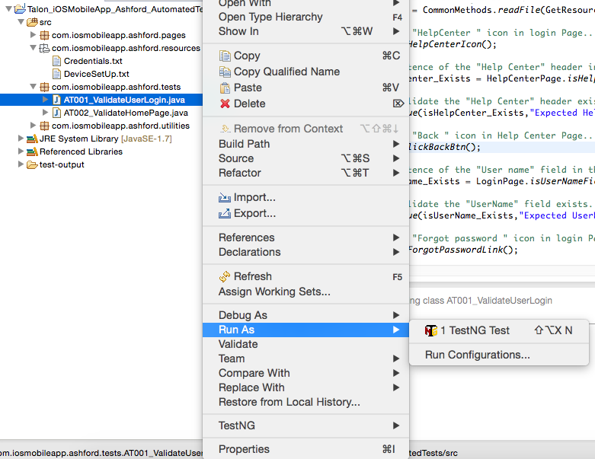
Run the main test case using TestNg Test as shown in the below screen shot.

After running the test cases we can see the results in console.

After Running the tests

